42U ENCLOSURE 19" CABINET 800X600 FLOOR STANDING DATA RACK - ECO NETCAB
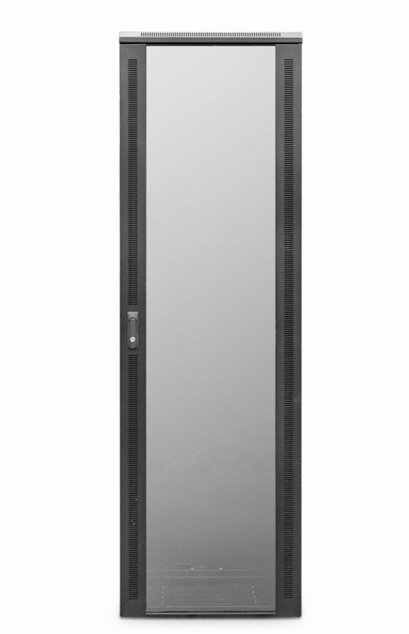

DESCRIPTION
The LMS Data EcoNetCab range of Enterprise-level data cabinets are professionally assembled in the UK with the quality and features you’ve come to expect from LMS Data. Available for a choice of professional installation scenarios, built from the ground up with quality alloys, robust powder coating and of course features to make pre and post installation easy, including adjustable front and rear ETSI 19-inch mount posts, gland plates, removable side panels and left/right hinged front safety glass door and solid rear door.
Supplied as standard with a host of fitted accessories including fitted fan tray, front cable management tray, vented shelf, castors and jacking feet together with M6 captive nut and bolt kit. Saving you both time and money for all your professional data installations.

SPECIFICATIONS
42U high 800W 600D
• ETSI 19” front/rear profiles, adjustable
• Lockable vented glass door, reversible
• Fitted 4-way fan tray
• Removable side panels, rear lockable door
• Integral Front Cable Management fitted
• Ideal for SME, IT Rooms, PBX & Broadcast
• Fitted castors and jacking feet (4))
• UK Assembled and quality assured

TECHNICAL INFO
SKU/MPN: CAB-FE-42U-86
EAN: 8400800020765
Weight: 90kg
Dimensions: 800(width) x600(depth) x2050mm (height)

FILES
Datasheet - CAB-FE-42U-86.pdf

